User Interface Sketches (Created with draw.io)

Sketch 1: Login Screen

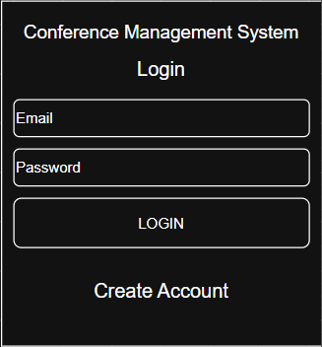

Sketch 2: Participant Dashboard

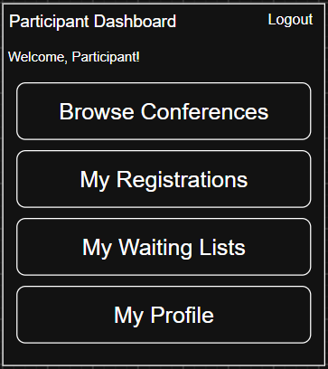

Sketch 3: Conference Details

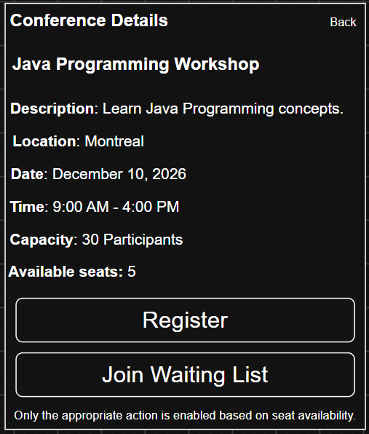

Sketch 4: My Registrations

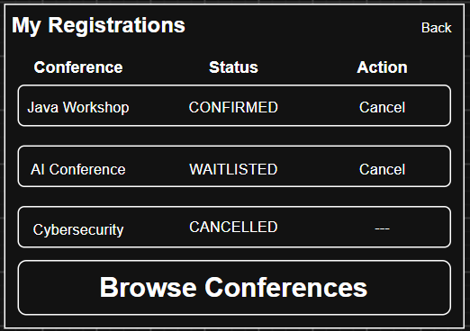

Sketch 5: Admin Dashboard



